Jim ‘Jimbo’ Zarifis
@ilivelifeill
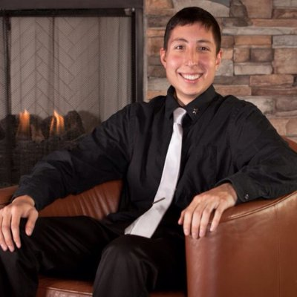 | 180 Pine Rock Ave, North Campus D31, Hamden, CT 06514  (203) 258-6195  jimbosports@gmail.com  ilivelifeill.com and jimbosports.com  Education  - 2nd year Graduate Student pursuing Masters at Southern CT State University in Sport and Entertainment Management  - 2014 BS in Sport Management concentration: Recreation and Leisure major from Southern CT State University (SCSU)

Skills
● Social Media Marketing ● Promotion ● Instagram ● Twitter ● Facebook ● YouTube
● LinkedIn ● Pinterest ● Wanelo ● Tumblr ● Blogger ● Leadership ● Social ●Networking
● Blogging ● Public Speaking ● Microsoft Office: Excel, PowerPoint, Word
● Event Management ● Event Planning ● Fundraising ● Blogging ● Community Outreach ●Advertising ● Blogging ● Newsletters ● Research ● Graphic Design ● Editing
Professional Experience
- 2005-Present: Owner and creator of ILiveLifeILL.com and JimboSports.com
- 2005-Present: Social Media Marketing for ILiveLifeILL.com and JimboSports.com
- 2014-Present: Graduate Assistant in the Recreation and Leisure Studies Department
- January 2014 - May 2014: Marketing & Promotions Intern w/ SCSU’s Athletic Communications Department
- March 2014 NCAA Division II Men’s Basketball East Regional Event Staff
- September-November 2013: Event Staff with SCSU Athletic Department
- May 2013 - August 2013: Internship with SCSU’s Campus Recreation
- 2013: Club Promoter for New Haven Nightlife
- 2013: Event Coordinator (One event at the West Haven Community House for project)
- June - August 2012: Treadwell summer camp counselor for Newtown Parks and Recreation
- 2006-2011: Treadwell Gate Attendant with Newtown Parks and Recreation
- January to May 2011: Computer Lab Assistant at SCSU
Honors and Awards
- 2010-2015 Susan Fund Scholarship - assists Fairfield County residents who have been diagnosed with cancer to pursue their educational goals through a scholarship grant
- Spring 2014: starred in “Jimbo's Inspirational Story: ILiveLife” documentary, a story of how I overcame challenges
- 2014-2015: Graduate Student Affairs Committee
- 2014-2015: Graduate Student Affairs Website Committee
- 2014-2015: Recreation Club Assistant Supervisor
- 2013-2014: President of the SCSU Student Recreation Club
- 2013: Damian O’Neil Memorial Scholarship - given to a student who contributes to the university and community with equal importance as his academic career
- 2011 & 2012: Academic Achievement Award - over a 3.0 GPA requirement
- June 2004 & 2008: Honorary Chair at Newtown Relay for Life
Certifications
- 2014: Mediation from Southern Connecticut State University
Volunteer Work
- August 2013-present: Camp Rising Sun Camp Week Camp Counselor volunteer
- 2015: Keynote speaker for New Fairfield Relay For Life
- April 2012, ‘13, ’14 - 6th, 7th & 8th Annual Jail N’ Bail philanthropy event staff for Special Olympics CT
- April 2014 - Delta Phi Epsilon sorority’s philanthropy event volunteer, all proceeds going to the Cystic Fibrosis Foundation
- April 2014 - Alpha Sigma Alpha’s Buzz-A-Thon philanthropy event staff raising money to send children diagnosed with cancer to Camp Rising Sun
- March 2014 - Camp Rising Sun Mini-Camp Weekend Camp Counselor volunteer
- March 2013 & ’14 - Disability Resource Center’s Stuff a Shuttle donation event volunteer for New Haven’s homeless
- November 2013- Connecticut Recreation and Parks Association conference volunteer
- November and January 2013- Beta Mu Sigma’s Special Olympics Athlete Formal volunteer
- June 2013 - Ben’s Lighthouse for Newtown Children Master of Ceremony
- June 2012 & ’13 - Summer Special Olympics Connecticut volunteer
- 2010 and 2013 - Keynote speaker at SCSU Relay for Life
- April 2012 & ’13- The Big Event volunteer, cleaning up the streets of New Haven, CT
- March 2013 - Beta Mu Sigma’s First Annual Wine tasting event volunteer
- 2013-2014 Social Media and Website Chair for Beta Mu Sigma Fraternity
- 2013 SCSU Homecoming Department Judge
- 2012-2013 Treasurer of the SCSU Recreation Club
- 2012-2013 Social Chair for Beta Mu Sigma Fraternity
- 2012-2013 Public Relations Chair Greek Life Council Chair
- 2011-2012 Greek Life Council Chair for Beta Mu Sigma Fraternity
- September 2012 - Day Of Service volunteer, a day to give back to the community
- April 2012 - Special Olympics Connecticut Urban Youth Day volunteer

